**Datasetst**

**Modes**

**Connected Mode**

**Disconnected Mode**

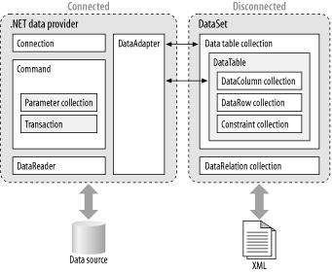

## Connected and Disconnected Data

As mentioned earlier, ADO.NET supports two different programming environments: connected and disconnected.

The *connected* environment provides forward-only, read-only access to data in the data source and the ability to execute commands against the data source. The connected classes provide a common way to work with connected data regardless of the underlying data source. They include Connection, Command, DataReader, Transaction, ParameterCollection, and Parameter classes.

The *disconnected* environment allows data retrieved from the data source to be manipulated and later reconciled with the data source. The disconnected classes provide a common way to work with disconnected data regardless of the underlying data source. They include the DataSet, DataTable, DataColumn, DataRow, Constraint, DataRelationship, and DataView classes.

Finally, ADO.NET introduces the connected DataAdapter class to bridge the data source and disconnected classes by way of the connected classes. The DataAdapter is an abstraction of the connected classes that simplifies filling the disconnected DataSet or DataTable classes with data from the data source and updating the data source to reflect any changes made to the disconnected data. [Figure 1-1](https://www.oreilly.com/library/view/adonet-in-a/0596003617/ch01s02.html#adonetian-CHP-1-FIG-1) shows the relationship between the connected and disconnected classes in ADO.NET.

disconnected mode eger databaseden tez tez data gotuturukse istifade etmek daha yaxsidir.

connected mode da ise eger databaseden datani gec gec (mes. 1 gunden bir) gotururse istifade etmek yaxsidir.